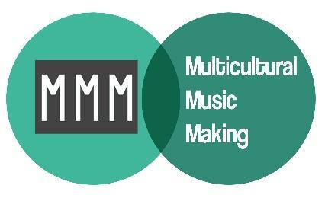
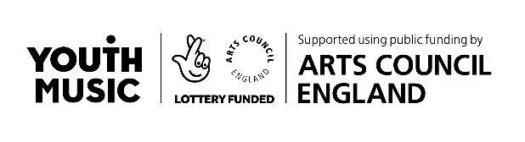
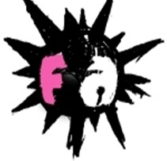

Dear Applicant
Project Manager, Multicultural Music Making (MMM)
Thank you for your interest in the Project Manager opportunity with MMM and Friction Arts.
Please find enclosed:
- An overview of the company, the project and the role
- A job description & person specification
- Our recruitment process & timeline
- Application form & equal opportunities monitoring form
Additional information about the company and our work can be found on our website at www.frictionarts.com
As detailed in the attached pack, as an alternative to completing the full application form in writing, we are happy to accept an anonymised CV in place of Questions 1 and 2, and responses to Questions 3 and/or 4 can be submitted as an audio voice recording .
The deadline for completed applications (including responses to ALL questions in any format) is 12pm noon on Monday 16th November 2020. We will aim to notify candidates as to whether they have been shortlisted by Tuesday 17th November 2020.
Please send completed applications to jobs@frictionarts.com
Interviews will be held on Thursday 19th and Friday 20th November 2020 via Zoom.
We very much hope that you find the enclosed details interesting and that this position is the right opportunity for you.

Yours faithfully
Sandra Hall, Co-Director, Friction Arts
Natalie Mason, Creative Director, Multicultural Music Making

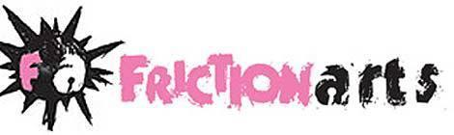
who we are and what we do

Friction have been making responsive, relevant artworks and projects locally, in our home city of
Birmingham and internationally for 30 years. We have no set artform or approach, instead responding to the needs and interests of our artists, audiences and participants and the particular context
(geographical, temporal, political) that we find ourselves in. To date this has included performances,
publications, events, workshops, programmes, interventions, exhibitions and installations using ‘all the art’. Friction’s vision is for a world where equality and creativity are flourishing.
We’re based in our own building in Digbeth, Birmingham, ‘The Edge’, where we host events, workshops, an art club for young people and where we make and plan our work. We’re currently undergoing a major refurbishment at the space to allow us to offer more space for local and hyperlocal organisations and community initiatives to meet and make work. We’re a Band 1 Arts Council National Portfolio Organisation.
In responding to the Covid-19 crisis, we have continued all of our regular programmes online and, in most cases, expanded delivery. We also supported 18 artists and freelancers to successfully bid for Arts Council’s emergency funding. We recently created a one-day experiment in Covid-aware performance and art called ‘Quiet Carnival’, with four shows over one day, featuring over 20 artists and performers from a range of disciplines.
Our current programme includes:
- Multicultural Music Making (MMM) (the project that this post is for) – a programme to change the way that music is taught, facilitating culturally-responsive music-making sessions for
children, supported by academic research. See next page for more info.
- Art Club – a ‘foundation course for 8-18 year olds’ with regular weekly sessions working with young people in developing their creative skills in all aspects of the visual arts. The only free resource of its kind in the city, delivered by professional artists.
- Walking Over Coals – artist development programme with ‘creative practitioners’ of all kinds of disciplines, with participants ranging from ages 18-69 and featuring musicians, illustrators, visual artists, sculptors, photographers and performers.
- Home – working with African-Caribbean older women looking at what ‘home’ means to them. Including exhibition at Birmingham Hippodrome with photographer Vanley Burke. Portraits of participants with augmented reality-triggered audio interviews. Video interviews, including with Vanley Burke.

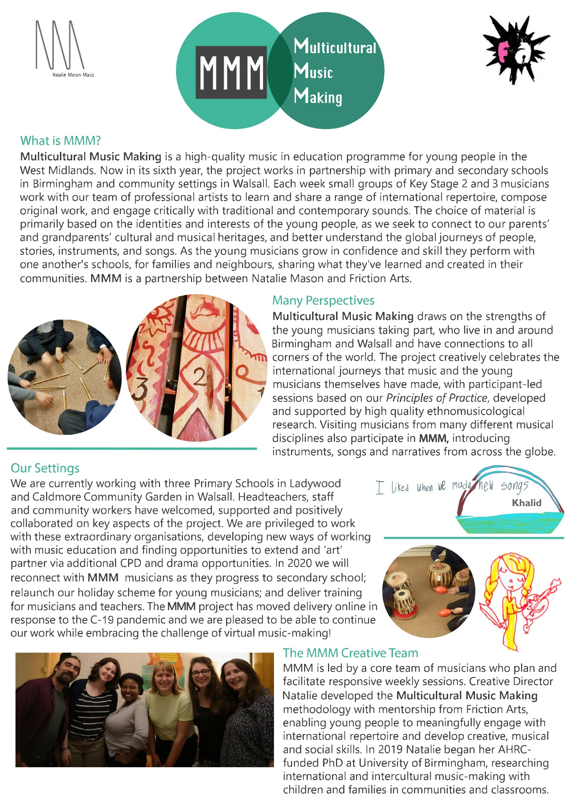

MMM Project Manager – Job Description

Purpose of the post:
- To provide administrative and project management support to the MMM programme.
- To develop relationships and communicate effectively with project partners, participants, Friction staff, freelance artists and stakeholders.
- To maintain administrative and communication systems, to ensure the smooth running of the project.

Responsible to: MMM Creative Director
Salary: £23,000 pro rata
Hours Of Work: 8 hours per week (flexible working)
Holidays: 22 days (pro rata) + Bank Holidays (pro rata)
Place of work: Remote working, with the potential for some in person work, depending on restrictions
Duration of contract: Fixed term (2 years): Nov 2020 – Oct 2022
Key Tasks:
Project Management:
- To establish & develop positive working relationships with participants, freelance artists, partner organisations, funders and commissioners
- To work with Friction’s Core Team, freelance artists, schools and partner organisations in the scheduling, planning and delivery of MMM
- To support participants of online projects by familiarising them with online platforms e.g. liaising with young people’s families around access and practice with technology, with the help of the MMM Support Worker
- To lead on areas of project administration, including issuing contracts, producing schedules and communicating with artists, partners and participants
- To monitor freelance artists’ timesheets and arrange prompt delivery of invoices to Friction Arts’ Finance Officer
- To work with Friction Arts and Artistic Staff to monitor project budgets
- Ensure legal compliance by ensuring project staff have up-to-date DBS certificates
- Arrange appropriate safeguarding training for project staff
- To produce meeting notes and risk assessments
- To work with the MMM team to monitor & evaluate the project
- To work with MMM team and Arts Award Advisor on delivering Arts Awards
- To comply with Friction’s Policies
- To organise larger sharing events for young people and families online or in-person where possible and appropriate
Development:
- To represent the project and its values to external bodies and professional organisations e.g. music services, music hubs, Youth Music, mac makes music, BCMG, THSH, Arts Council England
- To ensure appropriate content is produced for Youth Music and MMM websites
Plus any other duties as required in the general administrative running of the project.

Person Specification

 | Essential | Desirable
General | - Experience with music education projects  - An empathy with the ethos of the MMM project  - A familiarity with international music  - Enjoyment of working with a wide variety of people  - Positive and solution-focused outlook | - Musical experience e.g. knowledge of an instrument, experience of performance / composition / collaboration
Skills & abilities | - Excellent communication & interpersonal skills  - Excellent organisational & administrative skills  - Ability to work independently and as part of a team  - Ability to manage own workload  - Good IT skills  - Proven ability to manage project budgets | - Familiarity with online meeting platforms like Zoom
Experience | - Equivalent of at least 3 years professional experience of project coordination & administration  - Experience of working on arts, music or community projects  - Experience of producing bespoke evaluation frameworks for projects  - Experience of managing budgets | - Experience of delivering marketing activity  - Experience of event organising  - Experience of working in the West Midlands  - Experience of working with funder, Youth Music
Knowledge | - Knowledge of music, theatre, health or community arts, particularly in the West Midlands region | - Knowledge of current evaluation methodologies  - Knowledge of safeguarding procedures, particularly in relation to vulnerable young people and adults  - Knowledge of Arts Awards procedures and delivery
MMM Project Manager Recruitment – Process & Timescale
Application Stage Deadline: Monday 16th November 2020 - 12pm noon
Full Applications, including submissions in any alternative formats (attaching audio recordings and/or anonymised CVs) must be emailed to jobs@frictionarts.com

Shortlisting We aim to notify candidates by Tuesday 17th November 2020
Friction and the Creative Director will shortlist applicants, scoring applications against the Job Description & Person Specification.
Interview Stage Interview Dates: Thursday 19th and Friday 20th November 2020
We aim to have 30-45 minute interviews via Zoom. If any interview candidates are unfamiliar with Zoom, we can arrange a ‘practice call’ in advance. There will also be a short practical task which we will confirm if you are shortlisted and ask you to complete prior to the interview.

Job Application No. For Office Use Only

MMM Project Manager Application Form
To assist us with our equal opportunities procedures you are asked to only include personal details and referees on this page, which will be separated from your application and not made available to the short-listing panel. The equal opportunities monitoring form will also not be made available to the short-listing panel.
Application - Alternative Formats:
Questions 1 & 2 ask for details of your employment and education history, including voluntary work/ work experience. This information can be added to this form or if preferred, we will accept a CV, provided personal information has been removed.
Questions 3 & 4 ask about the qualities and experience you would bring to the post and why you are applying for it. Responses to these questions can be added to this form (500 word limit on each) or submitted as an audio voice recording (3 minute limit on each).
All documents and any audio files should be emailed no later than Monday 16th November 2020 - 12pm noon to jobs@frictionarts.com

Personal Details:
Name:
Address:
Phone:
Email Address:
Do you have any unspent criminal convictions? Yes / No (delete as appropriate)
How did you hear about this post?

Referees:
Please provide details for two referees. These will not be contacted until after interview stages.
Referee 1:
Name:
Organisation:
Telephone:
Email:

Referee 2:
Name:
Organisation:
Telephone:
Email:
1. Employment Details & Relevant Work Experience & Voluntary Roles
Please provide details of previous employment, voluntary work and work experience. Please give dates and a brief description of the position held. Begin with the most recent. Alternatively, as a response to this question, we will accept an attached CV provided personal information has been removed.

2. Education and Training
Please tell us about your educational qualifications; membership of any professional bodies and other training you have undertaken that you think may be relevant to this post. Please include dates and details of qualifications gained as appropriate. Alternatively, as a response to this question, we will accept an attached CV provided personal information has been removed.

3. What qualities and experience would you bring to this post?
Please indicate your ability to meet the particular requirements of the job description and person specification (word limit: 500 words). Alternatively, responses to this question can be submitted as an audio voice recording (time limit: 3 mins) - please don’t include your name in the recording.

4. Why have you applied for this post?
Please summarise why you are interested in this post, what you hope to gain and how this opportunity will help you in the future. (word limit: 500 words). Alternatively, responses to this question can be submitted as an audio voice recording (time limit: 3 mins) - please don’t include your name in the recording.

MMM Project Manager Recruitment - Equal Opportunities Monitoring Form
Friction Arts are committed to equal opportunities and comply with all legal legislation including the Equalities Act (2010). We are resolved to avoid any form of direct or indirect discrimination in employment and staff management policies and practices.
Friction’s Equal Opportunities policy exists to ensure equality of opportunity and the elimination of discrimination on the grounds of workers’: gender, marital/civil partnership status, gender reassignment, disability, race, age, sexual orientation, religion/belief or lack of any religion/belief, or pregnancy/maternity, plus needs of dependants and/or parenthood and to ensure that no job applicant is disadvantaged by conditions or requirements which cannot be shown to be justifiable.
Effective monitoring is part of this commitment and will help us to identify areas of under-representation where positive action may be needed. Your co-operation in completing this form, and returning it with your application, would be greatly appreciated. Any information which you give will be treated as strictly confidential and this form will be separated from your application on arrival. Should you not wish to answer any of the following questions it will not affect your application in any way.
How would you describe your ethnicity? Please tick one box.
Asian or Asian British
□ Bangladeshi
□ Indian
□ Pakistan
□ Other Asian background

Black or Black British
□ African
□ Caribbean
□ Other Black background

Middle Eastern and North Africa
□ Arab – Middle Eastern
□ Arab – North African
□ Other Middle Eastern Background

□ Prefer not to say
Mixed (dual heritage)
□ White & Asian
□ White & Black African
□ White & Caribbean
□ Other Mixed background

White
□ English
□ Irish
□ Scottish
□ Welsh
□ British
□ Other White Background

Other Ethnic Group
□ Other, please specify: _____________________________
How would you describe your gender? Please tick one box.
□ Male (incl. trans men) □ Female (incl. trans women) □ Non-Binary □ Other □ Prefer not to say
What is your age range?
□ 18 - 24 □ 25 - 34 □ 35 – 44 □ 45 - 54 □ 55 - 64 □ 65+ □ Prefer not to say
Do you consider yourself to have a disability?
□ Yes □ No □ Prefer not to say

