The Edge, 79-81 Cheapside

Deritend

Birmingham B12 0QH

Tel: 01217726160

E: [info@frictionarts.com](mailto:info@frictionarts.com)

Web: <https://www.frictionarts.com>

19thOctober 2021

 Dear Applicant

**Friction Arts Projects Manager permanent contract 4 days/week, £28K-£30k pro rata**

 Thank you for your interest in the Projects Manager opportunity with Friction Arts.

Please find enclosed:

* *An overview of the company and the role*
* *A job description & person specification*
* *Our Recruitment process & timeline*
* *Application form & equal opportunities monitoring form.*

Further information about the company and our work can be found on our website at [www.frictionarts.com](http://www.frictionarts.com/)

The deadline for completed applications (including responses to ALL questions in any format) is **Thursday 18th of November, midnight.**  We will aim to notify candidates as to whether they have been shortlisted by **Tuesday 23rd of November. Please return completed applications to** [**claire@frictionarts.com**](mailto:claire@frictionarts.com)**.**

Interviews will be held on **Monday 29th and Tuesday 30th of November. *\*Please allow at least 3 hours for the interview process.***Reasonable travel expenses will be reimbursed on production of receipts.

If you’d like further information you can email [claire@frictionarts.com](mailto:claire@frictionarts.com) or for an informal chat, telephone us on 01217726160

We very much hope that you find the enclosed details interesting and that this position is the right opportunity for you.

 Yours faithfully

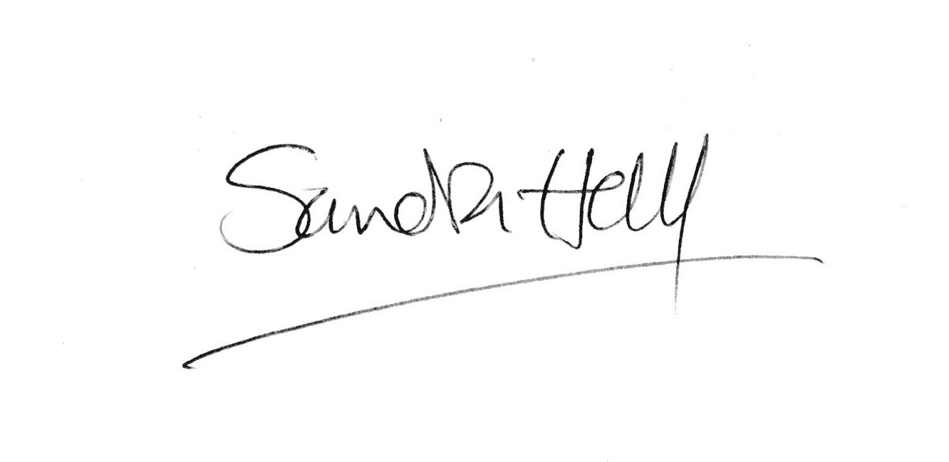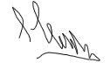

Sandra Hall, Lee Griffiths, Creative Directors of Friction Arts.

**An overview of the company and the role**

About Friction

We are a small, yet highly respected community arts organisation, an ACE NPO, and a grass-roots multidisciplinary artist-led connective, working locally and internationally. Our vision is a world where creativity and equality are flourishing.

Friction believe:-

* that art should be at the centre of everyday life
* that everyone should get the chance to enjoy art and the making of art
* that art is a powerful tool for personal and societal change
* that inequality and climate change are the most important issues facing us today

We have a 30-year history of making art for social and cultural change, celebration, and joy. We do this by creating bespoke, responsive, creative projects for a range of diverse people across all ages and demographics. We are a small, Band 1 Arts Council England National Portfolio Organisation. In 2021 we were shortlisted to the final 10 organisations for the Gulbenkian Foundation’s 1st UK Civic Arts Award.

We own our building, ‘the Edge’ in Deritend, Birmingham, between the gentrified creative quarter of Digbeth and low-income Highgate. Originally built as a boiled sweet warehouse in the 1920s, it’s been inhabited for industrial use, until we took over running the space in 2007. It’s our office, our studio and an event space and venue for a range of artistic and community uses.

**About the Role**

This is a new position we have created as our projects and company continue to grow. Working closely with the board and the Creative Directors you will be responsible for the delivery of our programme and the management of our people. We have a broad portfolio of responsive work currently, which shifts and changes at our communities’ requests, and our artists' inspiration. A list of our current projects can be found in the job description, each project has their own team of artists, support staff and management structure which you would support.

* 28 days holiday per year (pro rata) inc bank holidays
* Pension administered via NEST
* We do not operate overtime, instead a TOIL system is in place. We operate flexible working hours and work from our studio, and from home
* 6 month probationary period, with a review at 3 months
* A contribution to re-location costs, if applicable.

**Job description**

We are looking for an energetic and committed person to be the company’s projects manager, to oversee successful delivery of our socially-engaged programme of work. Our programme currently consists of:

* **How Were You?** We talk to people on the street about their pandemic experience whilst artist Ben Jones draws their portrait.  Their words are then added to the final portrait. We will be exhibiting and making publications from this work.
* **Art Club** Birmingham’s only free, weekly, out of school art lessons for diverse young people aged 8-18+. Art Club has been running for 8 years and alumni have gone on to take creative courses at university and forged their own careers in the arts.
* **Pass** Working with communities around parks across the city we are creating a performance ritual for people to come together to grieve for the losses incurred over the last two years, and to look forward to a future together.
* **MMM** Multicultural Music Making is a high-quality music in education programme for young people in the West Midlands. Now in its sixth year, the project works in partnership with primary and secondary schools in Birmingham and community settings in Walsall. Each week small groups of Key Stage 2 and 3 musicians work with our team of professional artists to learn and share a range of international repertoire, compose original work, and engage critically with traditional and contemporary sounds.
* **A Word From the Wise**  Working with and commissioning new work from artists over the age of 50.
* **Spaces of Sanctuary** Supporting artist-led ‘closed’ events for specific communities and communities of interest.  Like Albert Smith’s ‘Boxing Clever’, regular salons with gay men over 50 engaging in activities and talking about issues that matter to them.  Germa Adan’s song circles and workshops with artists from the Global Majority who identify as women. ‘Stir’ regular wellbeing and creative sessions with mixed Heritage people who identify as women, led by Sarah Kaur.
* **Walking Over Coals** Artist support and development. From assisting artists with funding applications to helping them build exhibitions and projects. Professional development by stealth.
* **Culture Club**. After-school and out of school provision for young people from Global Majority backgrounds to explore theirs and their family’s identities through the prism of the arts.

**Key Tasks**

**Programme development:**

* To manage our creative programme of cultural events to connect arts audiences with the wider community
* To help deliver this programme in association with Friction’s team
* To ensure the programme meets Arts Council England’s Creative Case for Diversity and Let’s Create strategy
* To work with Friction’s core team to ensure that the programme links to and influences its core programme of participatory-focused work

**Partnership working:**

* To develop and maintain effective relationships with independent arts practitioners, arts organisations, community groups and individuals

**Programme delivery**

* To oversee and support delivery of Friction’s programme of projects
* To coordinate marketing and PR relating to the above
* To ensure that all work adheres to Friction Arts policies regarding Equal Opportunities, Safeguarding and Health and Safety
* To ensure that all activity is documented, archived and shared appropriately
* To manage budgets, income and expenditure in accordance with company processes and to provide information regarding budgets in a timely manner to the Finance Officer
* To assist the company in developing fundraising and sponsorship
* To maintain effective evaluation and monitoring and to provide the company with data to upload to Audience Finder
* To help develop bespoke evaluation frameworks for programmes and projects

**Operational**

* To regularly report to the Creative Directors and to attend company meetings
* To represent and promote the programmes of work at external events, such as community networks, local government, and the arts and cultural sector

**Digital**

* To help develop digital platforms to distribute live work (e.g. streaming, YouTube, Facebook Live, etc)
* To use digital resources for archiving and documenting of Friction’s work and developing distribution
* To produce social media posts and other content for marketing purposes

**Person specification**

*Essential*

* Demonstrable experience of project management
* A proven ability to manage people and teams of people
* A high level of organisational skill
* A commitment to connecting the arts with the wider community
* An ability to communicate effectively with a wide range of stakeholders
* An understanding of key issues relating to under-represented communities and their access to arts and cultural production
* Knowledge and understanding of appropriate national networks: cultural, community, socially engaged practises.
* Ability to make informed artistic judgements and ensure high quality artistic outcomes
* A high level of understanding of the ability of the arts to create societal and political change
* A willingness to work flexible and sometimes unsocial hours
* A good understanding of digital processes for recording and distributing live work
* Experience of monitoring and evaluating arts and cultural projects

*Desirable*

* Lived experience of under-represented communities
* Experience of managing projects in a culturally diverse context
* Public speaking and presentation skills
* Experience of marketing and PR campaigns
* Knowledge of Birmingham’s arts and cultural sector
* Full driving licence

Application process: Please fill in the application form below, and the equal opportunities monitoring form. Applications will be anonymised before going to panel. Please return completed pack to [claire@frictionarts.com](mailto:claire@frictionarts.com) **by 18th November 2021 12am midnight.**

|  |
| --- |
| **Personal Details** |

Surname: Forename:

Other names:

Address 1:

Home telephone number: Mobile telephone number:

E-mail address:

|  |
| --- |
| **Eligibility to work** |

**Do you have permission to work in the UK?**

*If your answer is yes you may be required to provide evidence of your right to work in the UK at the interview stage of the recruitment process, and failure to do this will mean that your application will not be taken any further.*

|  |
| --- |
| **Current/ Most Recent Employment (Paid or Unpaid)** |

Name of organisation: Job title:

Date of appointment: Current or final salary/wage:

Period of notice required: Leaving date if not now working:

Give a brief outline of your responsibilities:

Reason for leaving (or for seeking other employment):

|  |
| --- |
| **Recent Employment (Paid or Unpaid)** |

Name of organisation: Job title:

Start of appointment: End of appointment:

Salary/wage (if any):

Give a brief outline of your responsibilities:

Reason for leaving (or for seeking other employment):

|  |
| --- |
| **Recent Employment (Paid or Unpaid)** |

Name of organisation: Job title:

Start of appointment: End of appointment:

Salary/wage (if any):

Give a brief outline of your responsibilities:

Reason for leaving (or for seeking other employment):

|  |
| --- |
| **Education, Training & Professional Qualifications** |

|  |  |  |  |
| --- | --- | --- | --- |
| **School/College/University/Employment** | **Dates Attended** | **Qualifications** | **Grade** |
|  |  |  |  |
|  |  |  |  |
|  |  |  |  |
|  |  |  |  |
|  |  |  | **Continued below** |

Using the *job description* and *person specification* as a guide please outline how your skills and experience meet the criteria for this post, and why you'd like to work with us.

|  |
| --- |
|  |

**Referees**

Please give the name and address of two referees. Where possible referees should have known you at work/school/college and one referee should be your present or most recent employer (if applicable):

Name: Name:

Address: Address:

Telephone number: Telephone number:

Occupation: Occupation:

May we request reference: May we request a reference:

only after offer of employment only after offer of employment

at any time at any time

|  |
| --- |
| **Declaration** |

**To the best of my knowledge the information on the application form and equal opportunities monitoring form is correct.**

**Signature: Date:**

To monitor the effectiveness of our equal opportunities recruitment policy, it is important to collect information which might identify possible direct and indirect barriers to employment. In line with our commitment, any information provided is entirely confidential, and is not part of any selection procedure.

**Post applied for:**

**Please state how you found out about the job**

|  |
| --- |
| MONITORING FORM |

|  |
| --- |
| Personal Details |

**Name:**

**Date of Birth:**

**Gender: (please select)**

Female (including transwoman)

Male (including transman)

Non-Binary (e.g. androgyne)

Prefer not to say

Is your gender identity different to the sex you were assumed to be at birth? (Please delete as appropriate).

Yes/No

|  |
| --- |
| Neurodiversity, Disability, and/or impairment |

**Do you identify as:**

A deaf or disabled person, or have a long-term health condition

Non-disabled

Prefer not to say

If you are neurodivergent, we can make adjustments to the application process. Please tell us if we need to make adjustments for you.

|  |
| --- |
| Cultural Diversity |

Please tick the ethnic category that best represents you. As you make your decision, please think about what ethnic group means to you, that is, how you see yourself. Your ethnic category is a mixture of culture, religion, skin colour, language and the origins of yourself and your family. It is not the same as nationality. *If you prefer not to say, that’s fine as well!*

## White

British

Irish

Any other white background, please state

## Asian or Asian British

Asian Bangladeshi

Asian Indian

Asian Pakistani

Any other Asian background, please state

## Black or Black British

Black African

Black Caribbean

Any other Black background, please state

## Chinese or other ethnic group

Chinese

Any other, please state

## Dual heritage

Dual Asian & White

Dual Black African & White

Dual Black Caribbean & White

Dual Chinese & White

Any other background, please state

|  |
| --- |
| Sexuality |

Please tick the box that best reflects your sexual orientation. If you prefer not to disclose this information, please select Prefer not to say.

Bisexual

Gay Man

Gay Woman/Lesbian

Heterosexual

Queer

Prefer not to say